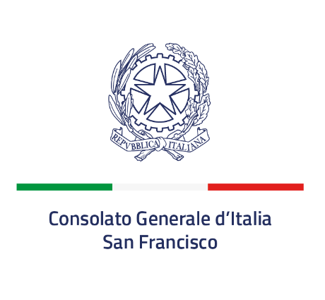
10th Week of Italian Cuisine in the World – San Francisco
“Italian cuisine between health, culture, and innovation”
Tuesday November 18
At the il Casaro North Beach restaurant in the heart of San Francisco’s Italian quarter, renowned Italian chef Vincenzo Vottero will prepare a special menu reflecting this year’s theme.
Thursday November 20
-6th edition of the “Carol Field” award
In collaboration with l’Accademia Italiana Della Cucina, the Italian Culture Institute and the Association of Professional Chefs of North America, the Consulate General of Italy in San Francisco will organize the sixth annual Carol Field Award for Italian Culture and Cuisine. The award commemorates Carol Field’s work in promoting Italian cuisine and culture on the West Coast, and aims to increase awareness on the West Coast of the benefits of Italian culture, the Mediterranean diet, and unique Italian food products.
During the X edition of the week of the Italian cuisine in the world
“Chef a scuola” – Italian chefs in the Bay Area will visit schools to present master classes.
- November 6 Chef a scuola! Chef Rudy Duran of the restaurant C’era una volta will present at the “la scuola paritaria italiana di San Francisco La Scuola International School”;
- November 10 Chef a scuola! Chef Rudy Duran of C’era una volta will present at Saints Peter and Paul School of San Francisco;
- 12 November Chef a scuola! Chefs Francesco Covucci and Vincenzo Vottero of the restaurant Il Casaro will present at Lowell High School of San Francisco;
- 14 November Chef a scuola! Chefs Elena Manunta and Mattia Marcelli of the restaurant Montesacro will present at Burlingame High School.

Multiple restaurants in the Bay Area and the greater Consular jurisdiction, chosen in conjunction with the Accademia della Cucina Italiana and the Honorary Consuls, will be offering a dedicated menu throughout the week. Participants include Italico, C’era una volta, il Casaro North Beach Pizzeria, il Casaro Osteria, Barbara, North Beach Restaurant, Mari e Monti, Terun, Impasto by Terun, Italico, and Ristobar.

